Proof of PAL Exception – Document Package
Applicant: Zhiyu Ge
Date of Birth: 2011-02-22
Application Type: Study Permit (Minor – Secondary School, Québec)

Table of Contents
Part 1 – Letter of Explanation
Explanation that the applicant is a minor (K–12 student in Québec) and therefore exempt from the PAL requirement, with reference to IRCC policy.
Part 2 – Certificat d’acceptation du Québec (CAQ)
Official Québec acceptance certificate authorizing studies in Québec.
Part 3 – Father’s Study Permit
Copy of father’s valid Canadian study permit as proof of legal status in Canada.
Part 4 – Birth Certificate
Official document proving parent–child relationship.
Part 5 – Mother’s Declaration of Consent
Signed consent letter from the mother, authorizing the child to study in Canada with her father, along with a copy of her identity document.

Part 1 – Letter of Explanation
To: Immigration, Refugees and Citizenship Canada (IRCC)
Subject: Proof of Provincial Attestation Letter (PAL) Exception
Dear Officer,
I am submitting this letter in response to the requirement for a Proof of Provincial or Territorial Attestation Letter (PAL or TAL) Exception in my daughter’s study permit application.
My daughter, Zhiyu Ge born on 2011-02-22, will be attending secondary school in Québec. According to IRCC’s official instructions, primary and secondary school students (kindergarten to grade 12) are exempt from the PAL requirement. Therefore, her application falls under this exemption category.

Applicant’s Situation:
- Applicant is a minor child (K–12 level).
- Destination province: Québec.
- The applicant will be living in Canada with her father, Qiyun Ge, who currently holds a valid study permit.
- The mother of the applicant, Mingli You, has provided a signed Declaration of Consent authorizing the child to study in Canada with her father.

Supporting Documents Attached:
- Certificat d’acceptation du Québec (CAQ) – Proof of authorization to study in Québec.
- Copy of father’s valid study permit – Proof of status in Canada.
- Birth certificate – Proof of parent–child relationship.
- Signed Declaration of Consent from mother with copy of her identity document.
Given the above, I kindly request that you accept this explanation and the attached supporting documents as proof that my daughter qualifies for the PAL exemption.
Thank you for your attention to this matter.
Sincerely,
Qiyun Ge
On behalf of Zhiyu Ge

Part 2 – Certificat d’acceptation du Québec (CAQ)
Part 3 – Father’s Study Permit
Part 4 – Birth Certificate

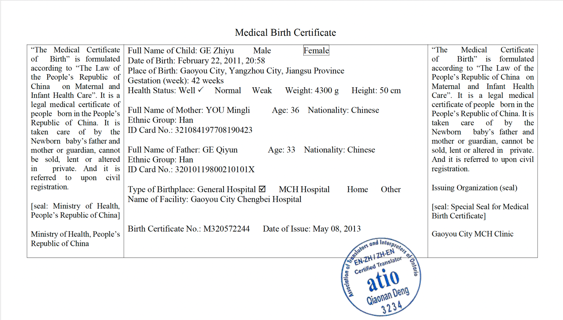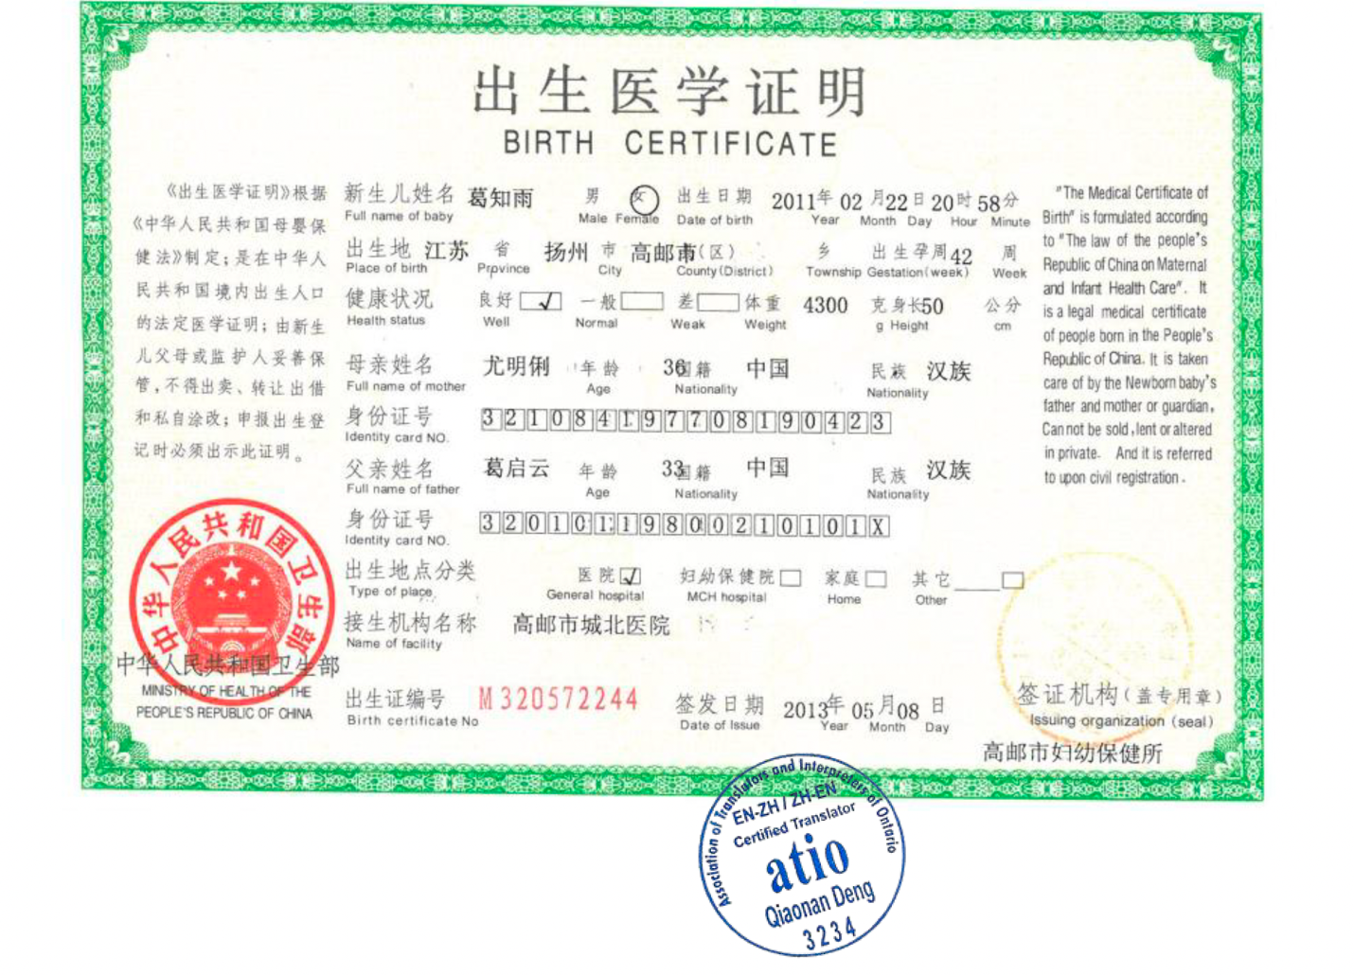

Part 5 – Mother’s Declaration of Consent

